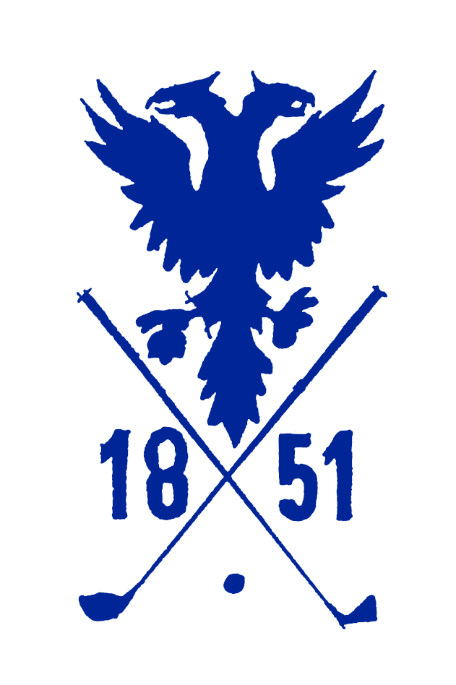

**Afternoon Tea**

##### **Selection of Finger Sandwiches**

Egg Mayonnaise & Cress

Smoked Salmon & Dill Crème Fraiche

Ayrshire Ham & Arran Mustard

Cucumber & Cream Cheese

**Selection of Scones**

Served with Clotted Cream & Preserves

**Filled Wraps**

**Sausage Rolls**

**Pork Pies**

**Sweet Tarts**

**Selection of Petit Cakes**

**Selection of Teas**

Earl Grey

English Breakfast

Green Tea

**£23.00 For 2 People**

Lanark Golf Club, The Moor, Whitelees Road, Lanark, ML11 7RX   
Phone: 01555 663219 Email: catering@lanarkgolfclub.co.uk

Lanark golf club